Μάθημα:

Στατιστική Μοντελοποίηση Πολύπλοκων Δικτύων

ΟΜΑΔΕΣ ΑΣΚΗΣΕΩΝ

(HOMEWORK SETS)

Κωδικός μαθήματος: ΦΥΣ 444

Εαρινό Εξάμηνο Ακαδημαϊκού έτους 2005-2006

Διδάσκοντες: Γιώργος Τσιρώνης & Γιώργος Νεοφώτιστος

Πηγή: Mark Newman, University of Michigan
Complex Systems 535, Winter 2005: Network Theory
http://www-personal.umich.edu/~mejn/courses/2004/cscs535/index.html

Ηράκλειο Κρήτης, Ιανουάριος 2006

ΟΜΑΔΑ ΑΣΚΗΣΕΩΝ 1

(HOMEWORK SET 1)

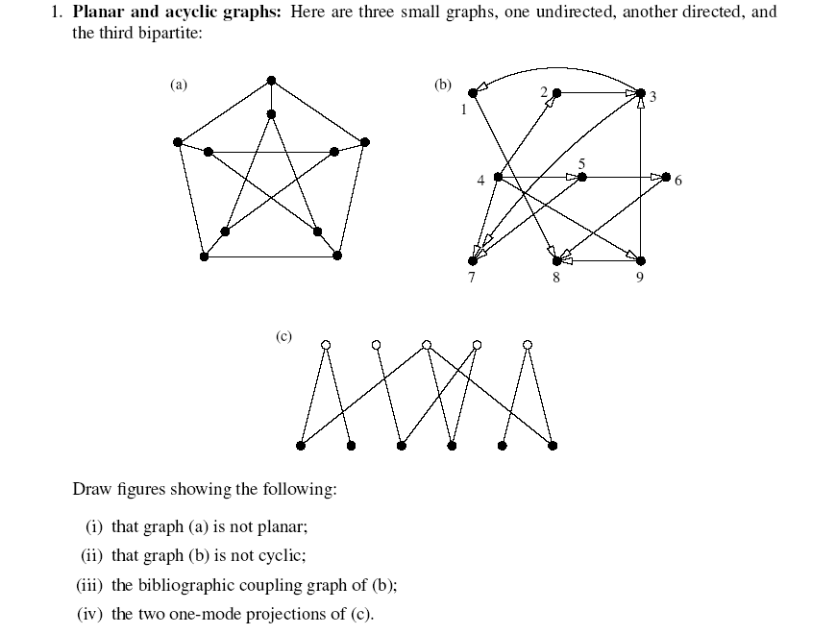

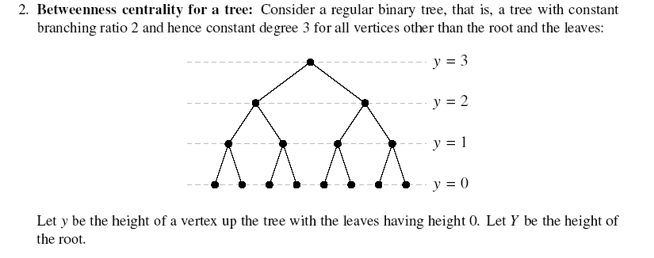

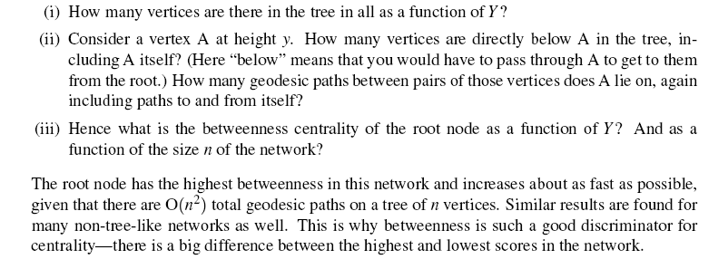

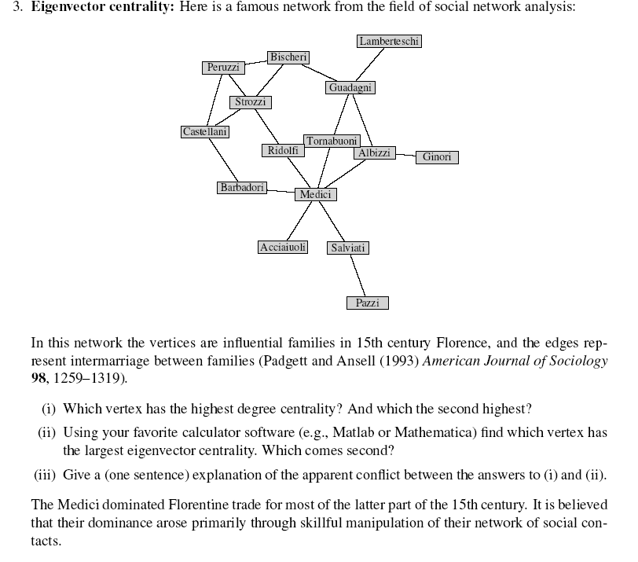

ΟΜΑΔΑ ΑΣΚΗΣΕΩΝ 2

(HOMEWORK SET 2)

ΑΣΚΗΣΗ 2.1
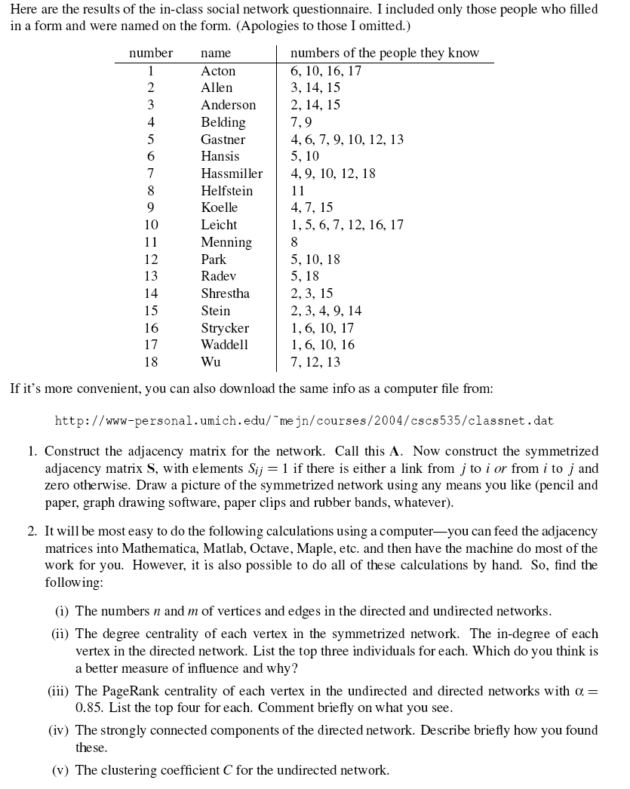
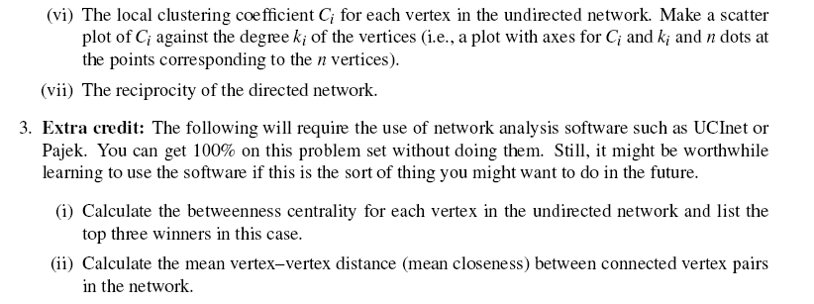

1 Acton 6 10 16 17
2 Allen 3 14 15
3 Anderson 2 14 15
4 Belding 7 9
5 Gastner 4 6 7 9 10 12 13
6 Hansis 5 10
7 Hassmiller 4 9 10 12 18
8 Helfstein 11
9 Koelle 4 7 15
10 Leicht 1 5 6 7 12 16 17
11 Menning 8
12 Park 5 10 18
13 Radev 5 18
14 Shrestha 2 3 15
15 Stein 2 3 4 9 14
16 Strycker 1 6 10 17
17 Waddell 1 6 10 16
18 Wu 7 12 13
ΑΣΚΗΣΗ 2.2
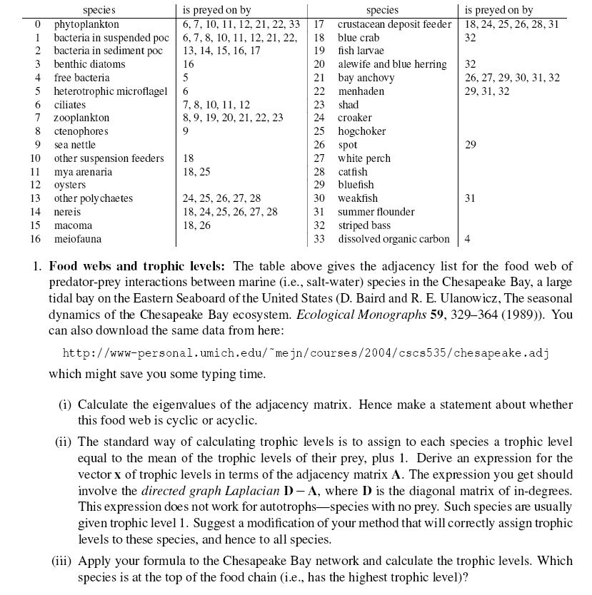

0 phytoplankton 8 [ 6 7 10 11 12 21 22 33 ]
1 bacteria_in_suspended_poc 8 [ 6 7 8 10 11 12 21 22 ]
2 bacteria_in_sediment_poc 5 [ 13 14 15 16 17 ]
3 benthic_diatoms 1 [ 16 ]
4 free_bacteria 1 [ 5 ]
5 heterotrophic_microflagel 1 [ 6 ]
6 ciliates 5 [ 7 8 10 11 12 ]
7 zooplankton 7 [ 8 9 19 20 21 22 23 ]
8 ctenophores 1 [ 9 ]
9 sea_nettle 0 [ ]
10 other_suspension_feeders 1 [ 18 ]
11 mya_arenaria 2 [ 18 25 ]
12 oysters 0 [ ]
13 other_polychaetes 5 [ 24 25 26 27 28 ]
14 nereis 6 [ 18 24 25 26 27 28 ]
15 macoma 2 [ 18 26 ]
16 meiofauna 0 [ ]
17 crustacean_deposit_feeder 6 [ 18 24 25 26 28 31 ]
18 blue_crab 1 [ 32 ]
19 fish_larvae 0 [ ]
20 alewife_and_blue_herring 1 [ 32 ]
21 bay_anchovy 6 [ 26 27 29 30 31 32 ]
22 menhaden 3 [ 29 31 32 ]
23 shad 0 [ ]
24 croaker 0 [ ]
25 hogchoker 0 [ ]
26 spot 1 [ 29 ]
27 white_perch 0 [ ]
28 catfish 0 [ ]
29 bluefish 0 [ ]
30 weakfish 1 [ 31 ]
31 summer_flounder 0 [ ]
32 striped_bass 0 [ ]
33 dissolved_organic_carbon 1 [ 4 ]

ΟΜΑΔΑ ΑΣΚΗΣΕΩΝ 3

(HOMEWORK SET 3)

ΑΣΚΗΣΗ 3.1
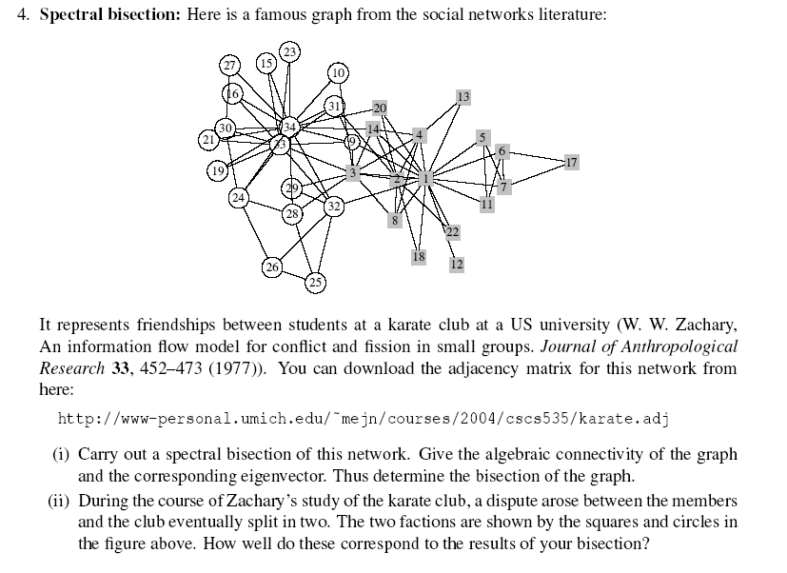
DATASET για την Άσκηση 3.1
0 1 1 1 1 1 1 1 1 0 1 1 1 1 0 0 0 1 0 1 0 1 0 0 0 0 0 0 0 0 0 1 0 0
1 0 1 1 0 0 0 1 0 0 0 0 0 1 0 0 0 1 0 1 0 1 0 0 0 0 0 0 0 0 1 0 0 0
1 1 0 1 0 0 0 1 1 1 0 0 0 1 0 0 0 0 0 0 0 0 0 0 0 0 0 1 1 0 0 0 1 0
1 1 1 0 0 0 0 1 0 0 0 0 1 1 0 0 0 0 0 0 0 0 0 0 0 0 0 0 0 0 0 0 0 0
1 0 0 0 0 0 1 0 0 0 1 0 0 0 0 0 0 0 0 0 0 0 0 0 0 0 0 0 0 0 0 0 0 0
1 0 0 0 0 0 1 0 0 0 1 0 0 0 0 0 1 0 0 0 0 0 0 0 0 0 0 0 0 0 0 0 0 0
1 0 0 0 1 1 0 0 0 0 0 0 0 0 0 0 1 0 0 0 0 0 0 0 0 0 0 0 0 0 0 0 0 0
1 1 1 1 0 0 0 0 0 0 0 0 0 0 0 0 0 0 0 0 0 0 0 0 0 0 0 0 0 0 0 0 0 0
1 0 1 0 0 0 0 0 0 0 0 0 0 0 0 0 0 0 0 0 0 0 0 0 0 0 0 0 0 0 1 0 1 1
0 0 1 0 0 0 0 0 0 0 0 0 0 0 0 0 0 0 0 0 0 0 0 0 0 0 0 0 0 0 0 0 0 1
1 0 0 0 1 1 0 0 0 0 0 0 0 0 0 0 0 0 0 0 0 0 0 0 0 0 0 0 0 0 0 0 0 0
1 0 0 0 0 0 0 0 0 0 0 0 0 0 0 0 0 0 0 0 0 0 0 0 0 0 0 0 0 0 0 0 0 0
1 0 0 1 0 0 0 0 0 0 0 0 0 0 0 0 0 0 0 0 0 0 0 0 0 0 0 0 0 0 0 0 0 0
1 1 1 1 0 0 0 0 0 0 0 0 0 0 0 0 0 0 0 0 0 0 0 0 0 0 0 0 0 0 0 0 0 1
0 0 0 0 0 0 0 0 0 0 0 0 0 0 0 0 0 0 0 0 0 0 0 0 0 0 0 0 0 0 0 0 1 1
0 0 0 0 0 0 0 0 0 0 0 0 0 0 0 0 0 0 0 0 0 0 0 0 0 0 0 0 0 0 0 0 1 1
0 0 0 0 0 1 1 0 0 0 0 0 0 0 0 0 0 0 0 0 0 0 0 0 0 0 0 0 0 0 0 0 0 0
1 1 0 0 0 0 0 0 0 0 0 0 0 0 0 0 0 0 0 0 0 0 0 0 0 0 0 0 0 0 0 0 0 0
0 0 0 0 0 0 0 0 0 0 0 0 0 0 0 0 0 0 0 0 0 0 0 0 0 0 0 0 0 0 0 0 1 1
1 1 0 0 0 0 0 0 0 0 0 0 0 0 0 0 0 0 0 0 0 0 0 0 0 0 0 0 0 0 0 0 0 1
0 0 0 0 0 0 0 0 0 0 0 0 0 0 0 0 0 0 0 0 0 0 0 0 0 0 0 0 0 0 0 0 1 1
1 1 0 0 0 0 0 0 0 0 0 0 0 0 0 0 0 0 0 0 0 0 0 0 0 0 0 0 0 0 0 0 0 0
0 0 0 0 0 0 0 0 0 0 0 0 0 0 0 0 0 0 0 0 0 0 0 0 0 0 0 0 0 0 0 0 1 1
0 0 0 0 0 0 0 0 0 0 0 0 0 0 0 0 0 0 0 0 0 0 0 0 0 1 0 1 0 1 0 0 1 1
0 0 0 0 0 0 0 0 0 0 0 0 0 0 0 0 0 0 0 0 0 0 0 0 0 1 0 1 0 0 0 1 0 0
0 0 0 0 0 0 0 0 0 0 0 0 0 0 0 0 0 0 0 0 0 0 0 1 1 0 0 0 0 0 0 1 0 0
0 0 0 0 0 0 0 0 0 0 0 0 0 0 0 0 0 0 0 0 0 0 0 0 0 0 0 0 0 1 0 0 0 1
0 0 1 0 0 0 0 0 0 0 0 0 0 0 0 0 0 0 0 0 0 0 0 1 1 0 0 0 0 0 0 0 0 1
0 0 1 0 0 0 0 0 0 0 0 0 0 0 0 0 0 0 0 0 0 0 0 0 0 0 0 0 0 0 0 1 0 1
0 0 0 0 0 0 0 0 0 0 0 0 0 0 0 0 0 0 0 0 0 0 0 1 0 0 1 0 0 0 0 0 1 1
0 1 0 0 0 0 0 0 1 0 0 0 0 0 0 0 0 0 0 0 0 0 0 0 0 0 0 0 0 0 0 0 1 1
1 0 0 0 0 0 0 0 0 0 0 0 0 0 0 0 0 0 0 0 0 0 0 0 1 1 0 0 1 0 0 0 1 1
0 0 1 0 0 0 0 0 1 0 0 0 0 0 1 1 0 0 1 0 1 0 1 1 0 0 0 0 0 1 1 1 0 1
0 0 0 0 0 0 0 0 1 1 0 0 0 1 1 1 0 0 1 1 1 0 1 1 0 0 1 1 1 1 1 1 1 0
ΑΣΚΗΣΗ 3.2
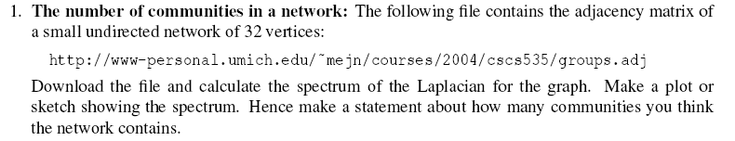

ΑΣΚΗΣΗ 3.3 & ΑΣΚΗΣΗ 3.4
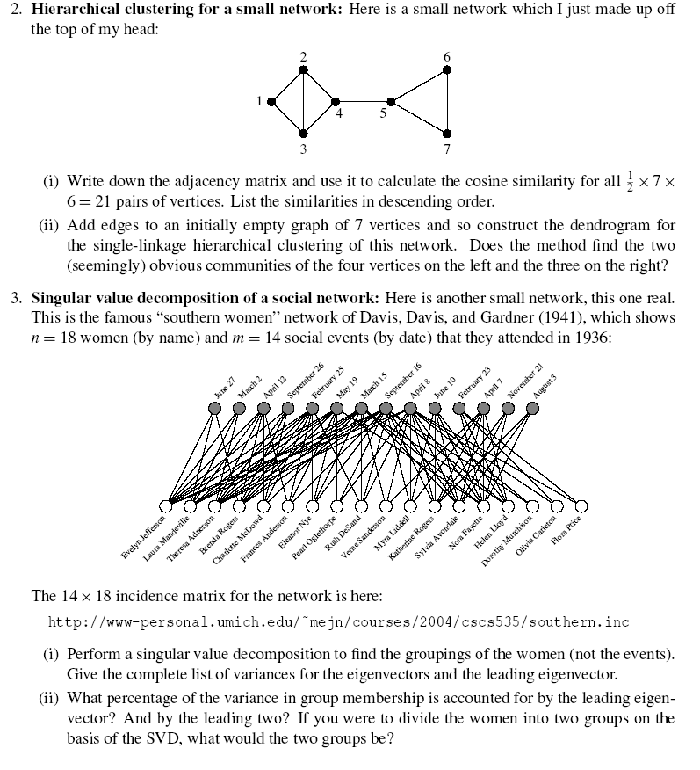

DATASET για την Άσκηση 3.2
0 1 1 0 0 1 1 1 0 0 0 0 0 0 0 0 0 0 0 0 0 0 0 0 0 0 0 0 0 0 0 0
1 0 0 1 1 1 1 1 0 0 0 0 0 0 0 0 0 0 0 0 1 0 0 0 0 0 0 0 0 0 0 0
1 0 0 0 0 1 1 1 0 0 0 0 0 0 0 0 0 0 0 0 0 0 0 0 0 0 0 0 0 0 0 0
0 1 0 0 1 1 0 1 0 0 0 0 0 0 0 0 0 0 1 0 0 0 0 0 0 0 0 0 0 0 0 0
0 1 0 1 0 1 1 1 0 0 0 0 0 0 0 0 0 0 0 0 0 0 0 0 0 0 0 0 0 0 0 0
1 1 1 1 1 0 1 1 0 0 0 0 0 0 0 0 0 0 0 0 0 0 0 0 0 1 0 0 0 0 0 0
1 1 1 0 1 1 0 0 0 0 0 0 0 0 0 0 0 0 0 0 0 0 0 0 0 0 0 0 0 0 0 0
1 1 1 1 1 1 0 0 0 0 0 0 1 0 0 0 0 0 0 0 0 0 0 0 0 0 0 0 0 0 0 0
0 0 0 0 0 0 0 0 0 1 1 1 1 1 1 1 0 0 0 0 0 0 0 0 0 0 0 0 0 0 0 0
0 0 0 0 0 0 0 0 1 0 1 0 0 0 0 0 0 0 0 0 0 0 0 0 0 0 0 0 0 0 0 0
0 0 0 0 0 0 0 0 1 1 0 0 1 0 0 1 0 0 0 0 0 0 0 0 0 0 0 0 0 0 0 0
0 0 0 0 0 0 0 0 1 0 0 0 1 1 1 0 0 0 0 0 0 0 0 0 0 0 0 0 0 0 0 0
0 0 0 0 0 0 0 1 1 0 1 1 0 1 1 1 0 0 0 0 0 0 0 0 0 0 0 0 0 0 0 0
0 0 0 0 0 0 0 0 1 0 0 1 1 0 1 1 0 0 0 0 0 0 0 0 0 0 0 0 0 0 0 0
0 0 0 0 0 0 0 0 1 0 0 1 1 1 0 1 0 0 0 0 0 0 0 0 0 0 0 0 0 0 0 0
0 0 0 0 0 0 0 0 1 0 1 0 1 1 1 0 0 0 0 0 0 0 0 0 0 0 0 0 0 0 0 0
0 0 0 0 0 0 0 0 0 0 0 0 0 0 0 0 0 0 1 1 0 0 1 1 0 0 0 0 0 0 0 0
0 0 0 0 0 0 0 0 0 0 0 0 0 0 0 0 0 0 1 0 1 1 0 1 0 0 0 0 0 0 0 0
0 0 0 1 0 0 0 0 0 0 0 0 0 0 0 0 1 1 0 0 0 1 1 1 0 0 0 0 0 0 0 0
0 0 0 0 0 0 0 0 0 0 0 0 0 0 0 0 1 0 0 0 1 1 1 0 0 0 0 0 1 0 0 0
0 1 0 0 0 0 0 0 0 0 0 0 0 0 0 0 0 1 0 1 0 1 1 1 0 0 0 0 0 0 0 0
0 0 0 0 0 0 0 0 0 0 0 0 0 0 0 0 0 1 1 1 1 0 0 1 0 0 0 0 0 0 0 0
0 0 0 0 0 0 0 0 0 0 0 0 0 0 0 0 1 0 1 1 1 0 0 1 0 0 0 0 0 0 0 0
0 0 0 0 0 0 0 0 0 0 0 0 0 0 0 0 1 1 1 0 1 1 1 0 0 0 0 0 0 0 0 0
0 0 0 0 0 0 0 0 0 0 0 0 0 0 0 0 0 0 0 0 0 0 0 0 0 1 0 0 0 1 1 0
0 0 0 0 0 1 0 0 0 0 0 0 0 0 0 0 0 0 0 0 0 0 0 0 1 0 0 1 1 1 0 1
0 0 0 0 0 0 0 0 0 0 0 0 0 0 0 0 0 0 0 0 0 0 0 0 0 0 0 1 0 1 1 0
0 0 0 0 0 0 0 0 0 0 0 0 0 0 0 0 0 0 0 0 0 0 0 0 0 1 1 0 1 1 0 0
0 0 0 0 0 0 0 0 0 0 0 0 0 0 0 0 0 0 0 1 0 0 0 0 0 1 0 1 0 1 1 0
0 0 0 0 0 0 0 0 0 0 0 0 0 0 0 0 0 0 0 0 0 0 0 0 1 1 1 1 1 0 0 1
0 0 0 0 0 0 0 0 0 0 0 0 0 0 0 0 0 0 0 0 0 0 0 0 1 0 1 0 1 0 0 1
0 0 0 0 0 0 0 0 0 0 0 0 0 0 0 0 0 0 0 0 0 0 0 0 0 1 0 0 0 1 1 0
DATASET για την Άσκηση 3.4

1 1 0 1 0 0 0 0 0 0 0 0 0 0 0 0 0 0
1 1 1 0 0 0 0 0 0 0 0 0 0 0 0 0 0 0
1 1 1 1 1 1 0 0 0 0 0 0 0 0 0 0 0 0
1 0 1 1 1 0 0 0 0 0 0 0 0 0 0 0 0 0
1 1 1 1 1 1 1 0 1 0 0 0 0 0 0 0 0 0
1 1 1 1 0 1 1 1 0 0 0 0 0 1 0 0 0 0
0 1 1 1 1 0 1 0 1 1 0 0 1 1 1 0 0 0
1 1 1 1 0 1 1 1 1 1 1 1 1 0 1 1 0 0
1 0 1 0 0 0 0 1 1 1 1 1 1 1 0 1 1 1
0 0 0 0 0 0 0 0 0 0 1 1 1 1 1 0 0 0
0 0 0 0 0 0 0 0 0 0 0 0 0 1 1 0 1 1
0 0 0 0 0 0 0 0 0 1 1 1 1 1 1 0 0 0
0 0 0 0 0 0 0 0 0 0 0 1 1 1 0 0 0 0
0 0 0 0 0 0 0 0 0 0 0 1 1 1 0 0 0 0

ΟΜΑΔΑ ΑΣΚΗΣΕΩΝ 4
(θα προστεθούν ασκήσεις)
ΑΣΚΗΣΗ 4.1
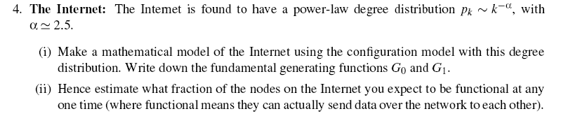
ΑΣΚΗΣΗ 4.2 & ΑΣΚΗΣΗ 4.3
